Summary
Insects: With the cooler weather this spring, and many fields still without crops emerged, there have been no reports yet of economic populations or levels of crop damage from insects. Some cutworms, wireworms and flea beetles are being noted, but just small levels so far.

Diseases: No disease issues were reported this week. Manitoba Agriculture conducts annual disease surveys across the province to assess and compare disease levels in major crops across regions. Interested in knowing the disease presence and severity in your field to support future crop management decisions? Sign up for a free field crop disease assessment – see details below.

Weeds: Annual weed growth has been slow due to cool weather. Recent rains and warming weather next week should bring a flush of new growth. Winter annuals like shepherd’s purse and stinkweed are starting to bolt and flower, and perennials like dandelion are flowering.

Dingy and redbacked cutworm are often two of the most abundant species in Manitoba
Entomology
Scouting Tips for Cutworms

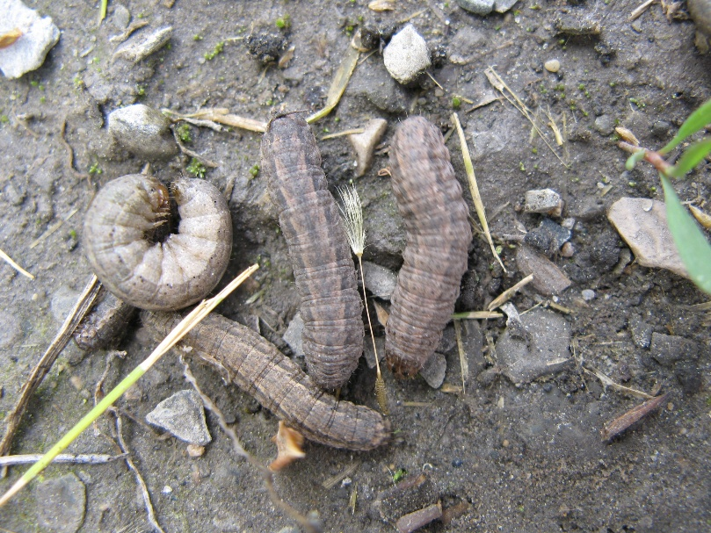
Dingy Cutworms
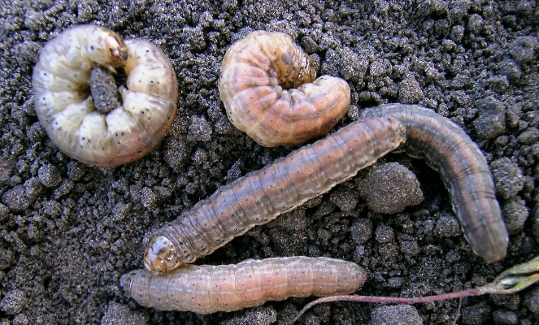
Redbacked cutworms
Note- diagonal markings that look like tire tracks, or "V's" on the back.

Here are a few scouting tips to consider when assessing levels of cutworms.
- Cutworms are nocturnal, feeding at night and hiding during the day. To find them while scouting fields, dig around damaged plants. If there is stubble or plant deris in the field, sometimes you will find them hiding under this.
- How deep cutworms are in the soil will depend on how old the larvae are and how moist the soil is. A study from Ontario on darksided cutworm found that younger larvae were generally 6 – 13 mm deep near the base of the host plant. Older larvae were just under the soil surface in wet weather, but in dry weather could be found at a depth of 8 - 10 cm (3 - 4 inches).
- Cutworms may be more abundant in patches or a specific area of a field.
- Note the size. Small larvae pose the greatest potential for damage as they still have to feed and grow. Given our cool spring so far, larvae are likely to be small still. Species that overwinter as partially grown larvae, such as dingy cutworm, may be larger than species that overwinter as eggs, such as redbacked cutworm.
More information on “Cutworms in Field Crops”, including nominal thresholds in various crops, is available at: https://www.gov.mb.ca/agriculture/crops/insects/pubs/cutworms-in-field-crops.pdf

Diseases
Annual Disease Surveys – A New Sign-Up System
Manitoba Agriculture has launched a new sign-up system for the 2026 provincial field crop disease surveys and is inviting producers and agronomists to participate.
In collaboration with industry partners, trained staff will assess disease levels in participating fields, supporting accurate, province-wide disease monitoring and management.
All information is kept confidential and reported only at the Rural Municipality level. Participating producers and agronomists will receive disease reports for their own fields.

Sign up via the link or QR code (1–2 minutes):
https://www.gov.mb.ca/agriculture/crops/plant-diseases/pubs/disease-survey-sign-up.pdf


Weeds
Canada fleabane
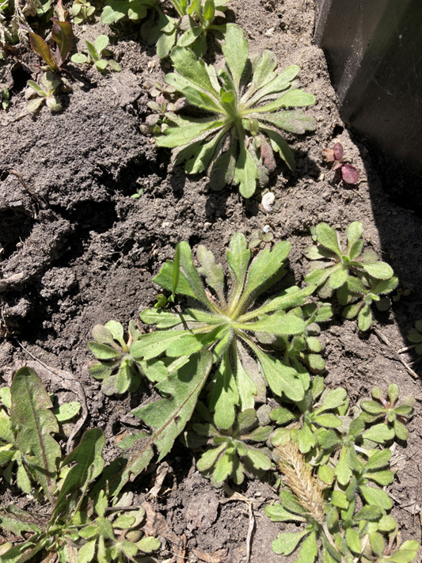

A lot of Canada fleabane showing up, here are several plants from the bed of my weed garden. Note the sparse hairs and notches on the leaf margins toward the tip of the leaves.

Giant ragweed
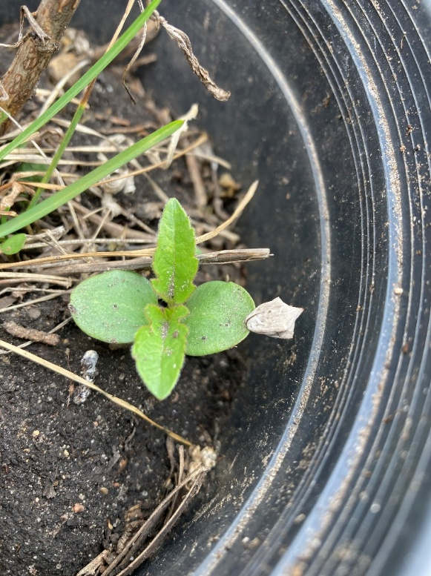

Sometimes Mother Nature leaves us a clue! Note the seed of giant ragweed still attached to the tip of the cotyledon.

Forecast

Diamondback moth
- Traps for diamondback moth were set up in ealy May.
- The main purpose is to determine regions where diamondback moth have blown in, and relative levels. Earlier arrival of higher levels in a region means potentially more generations and higher risk of damage to crops.
- Counts have so far been very low. Highest cumulative counts so far are 4, from a trap near Grandview in the Northwest, and 3 from traps near St. Joseph in the Central region, and Fisher Branch and Teulon in the Interlake.

True Armyworms
- Traps for true armyworm were set up in early May.
- Results are being entered and mapped on the Great Lakes and Maritimes Pest Monitoring Network website: https://experience.arcgis.com/experience/7164d23d488246d198dcf7a07d8c9021/page/Home/?views=Welcome
- To view the data, select TAW. The “Play” button at the bottom can be set so the map automatically advances (click middle arrow), or set to “Stop” and the arrows at either side of the button can be used to go forward or backward a week at a time.
- Larger dots mean more moths trapped. A Legend is provided to help interpret dot size.
- Note that for the week of May 18 -25, there are a couple of locations in the Interlake in the 50 – 98 range. Adults arriving would be looking for lush stands of grassy plants to lay their eggs into. Often forage grasses and winter cereals seem to be preferred sites, although spring cereals may be attractive as well in some years (probably less so this year for moths arriving in May).

Identification Quiz

Question: While digging in the soil, you may also come across the following insect. What are these?
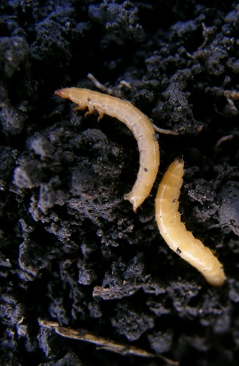
Answer: These are wireworms. Aside from being slender and yellowish, note that they just have 3 pair of small legs (behind the head on the thorax) but don’t have prolegs (the short, fleshy legs on the abdomen of caterpillars) like cutworms do.

Despite the common name wireworm, they are not really “worms”, but are the larval stage of a group of beetles called click beetles (Elateridae).

To report observations on insects, plant pathogens, or weeds that may be of interest or importance to farmers and agronomists in Manitoba, please send messages to one of the following Manitoba Agriculture Pest Management Specialists.

John Gavloski, Entomologist (204) 750-0594 Simon Huang, Field Crop Pathologist (204) 750-4248
Kim Brown, Weed Specialist (431) 344-0239

